SOFTWARE TESTING REPORT
TUTORIAL – 11: PYTHON AUTOMATION TESTING

Project Detail | Information
Student Name | Parth Fegade
Enrollment Number | 2504030100083
Programme | BCA — Semester 3
Practical | Tutorial – 11: Python Automation Testing
Testing Tools | Python, Selenium WebDriver, PyCharm, Google Chrome
Application Under Test | SauceDemo — saucedemo.com
Date | 29 October 2026

1. Aim
To analyze and perform automation testing in Python for website navigation, login forms, links, product selection, cart navigation, checkout forms, multi-page workflows, validation, and regression-testing scenarios.

2. Objectives
- Open the SauceDemo website in Google Chrome using Selenium WebDriver.
- Locate the username and password fields and submit valid login credentials.
- Verify that login navigates to the inventory/products page.
- Select a product and verify cart navigation.
- Complete the checkout form and validate the next checkout page.
- Test browser back and forward navigation.
- Display clear test outcomes in the PyCharm console and retain screenshots as evidence.

3. Tools and Technologies
Tool / Technology | Purpose
Python | Programming language used to write the automation script.
Selenium WebDriver | Automates browser actions and validates web page behavior.
PyCharm IDE | Environment used to create and execute the Python script.
Google Chrome | Browser used for the test execution.
WebDriverWait / Expected Conditions | Waits for elements or URL conditions before continuing.
SauceDemo | Demo e-commerce website used as the application under test.

4. Implementation Details
Parameter | Details
Project Name | Python Automation Testing
Application / Software | SauceDemo Web Application
Module | Navigation, Forms, Links and Multi-Page Workflow
SDLC Model | Agile (as stated in the practical handout)
Programming Language | Python
IDE / Tool | PyCharm
Automation Tool | Selenium WebDriver
Browser | Google Chrome
Test Data | Username, password, product selection and checkout details

5. Test Case Details
The test cases below follow the scenarios and expected outcomes described in Tutorial 11.
Test Case ID | Scenario | Expected Result | Observed Result | Status
TC-11-01 | Open website | SauceDemo opens in Chrome | Website opened successfully (console) | Pass
TC-11-02 | Valid login | User reaches inventory page | Login test reported PASS | Pass
TC-11-03 | Product selection | Selected product is added to cart | Product selection reported PASS | Pass
TC-11-04 | Open cart | Cart page opens | Cart navigation reported PASS | Pass
TC-11-05 | Checkout form | Checkout data is accepted | Checkout form reported PASS | Pass
TC-11-06 | Multi-page validation | Correct checkout page opens | Multi-page workflow reported PASS | Pass
TC-11-07 | Back/forward navigation | Browser navigates back and forward | Back/forward navigation reported PASS | Pass

6. Test Procedure
- Open PyCharm and create or open the Python project.
- Create the Python file named tutorial11.py.
- Install Selenium in the PyCharm terminal using: pip install selenium.
- Import webdriver, By, WebDriverWait, and expected_conditions as EC.
- Launch Chrome with webdriver.Chrome() and maximize the window.
- Open https://www.saucedemo.com/.
- Enter the valid username standard_user and password secret_sauce, then click Login.
- Wait for the URL to contain “inventory” and assert that the inventory page is open.
- Click the Add to cart button for Sauce Labs Backpack.
- Open the shopping cart and verify that the cart page is displayed.
- Click Checkout and fill the first name, last name, and postal-code fields with the test data specified in the practical.
- Click Continue and verify that the URL contains “checkout-step-two”.
- Navigate back and forward, then close the browser with driver.quit() in a finally block.
- Review the console output and capture screenshots of the code, execution results, login page, and product page.

7. Test Execution and Result Analysis
The supplied PyCharm console screenshot reports successful completion of the website, login, product selection, cart navigation, checkout form, multi-page workflow, and back/forward navigation checks. It also displays “Tutorial 11 Completed Successfully” and exit code 0. The supplied browser screenshots show the SauceDemo login screen with credentials entered and the inventory/products page after login.
The evidence included with this report supports the successful execution messages shown in the console. The supplied screenshots do not individually show every intermediate cart and checkout page, so those steps are recorded as reported by the console rather than independently verified from a separate browser screenshot.

8. SDLC–STLC Mapping
SDLC Phase | Corresponding STLC Phase | Testing Activity
Requirement Analysis | Requirement Analysis | Identify automation requirements.
System Design | Test Planning | Prepare automation scenarios.
Development | Test Case Development / Implementation | Develop Selenium scripts.
Testing | Test Execution | Execute automated scripts and record results.
Deployment | Test Closure | Verify and summarize test results.
Maintenance | Regression Testing | Re-run existing scenarios after changes.

9. Testing Activities and Deliverables
Activity | Deliverable / Artifact | Purpose
Identify automation requirements | Requirement List / SRS | Defines what should be tested.
Prepare automation scenarios | Test Plan | Defines the testing approach.
Develop Python Selenium script | Source Code | Automates the test cases.
Execute automated tests | Test Execution Report | Records observed test results.
Summarize testing | Test Summary Report | Communicates overall outcomes.
Re-execute important scenarios | Regression Report | Checks existing functionality after changes.

10. Roles and Responsibilities
Role | Responsibility | Phase Involved
Project Manager | Manages project activities | All phases
Business Analyst | Defines requirements | Requirement
System Analyst | Analyzes the system | Requirement / Design
Software Developer | Develops software | Development
Software Tester / QA Engineer | Performs testing | Testing
Database Administrator | Manages database | Development / Testing
Client / End User | Provides feedback | Testing / Deployment

11. Screenshot Evidence
The following images were supplied for this report and are included as execution evidence.
Screenshot 1 — PyCharm source code for Tutorial 11.
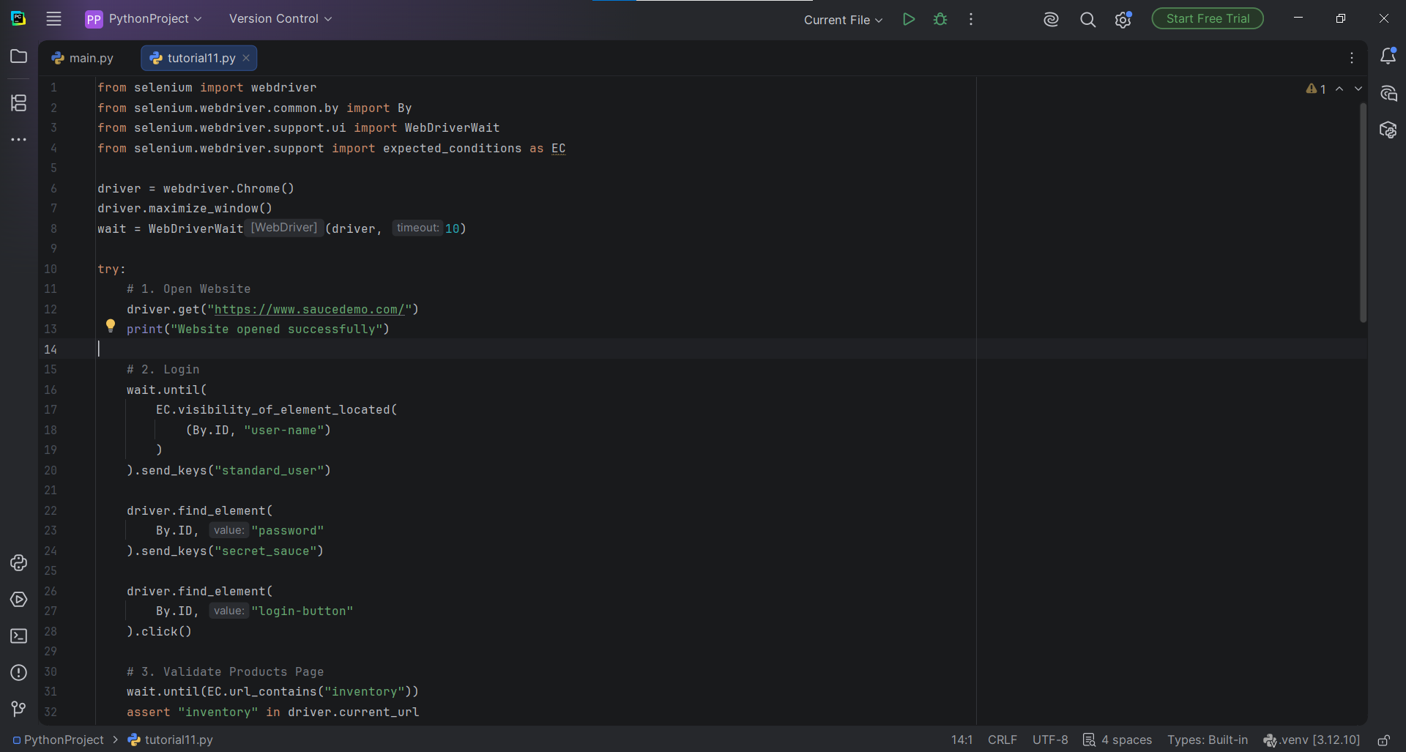

Screenshot 2 — PyCharm console output showing the test results.
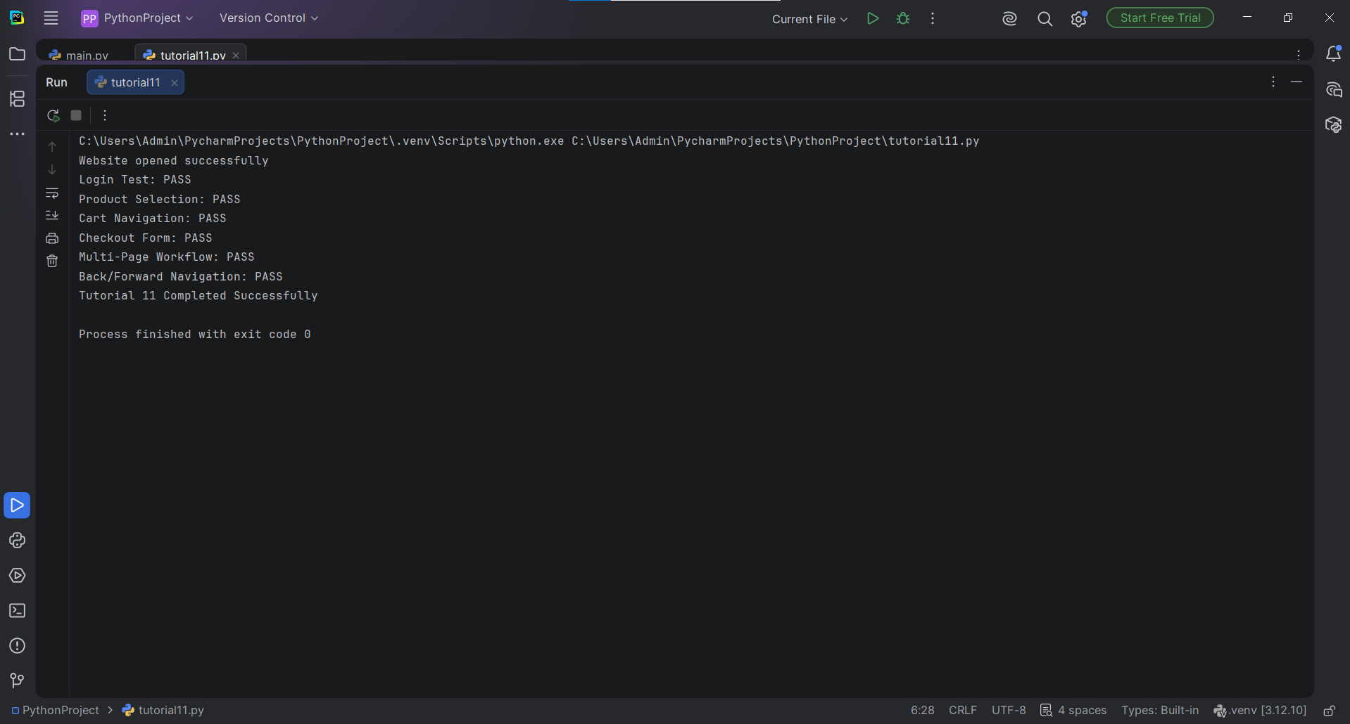

Screenshot 3 — SauceDemo login page with the test credentials entered.
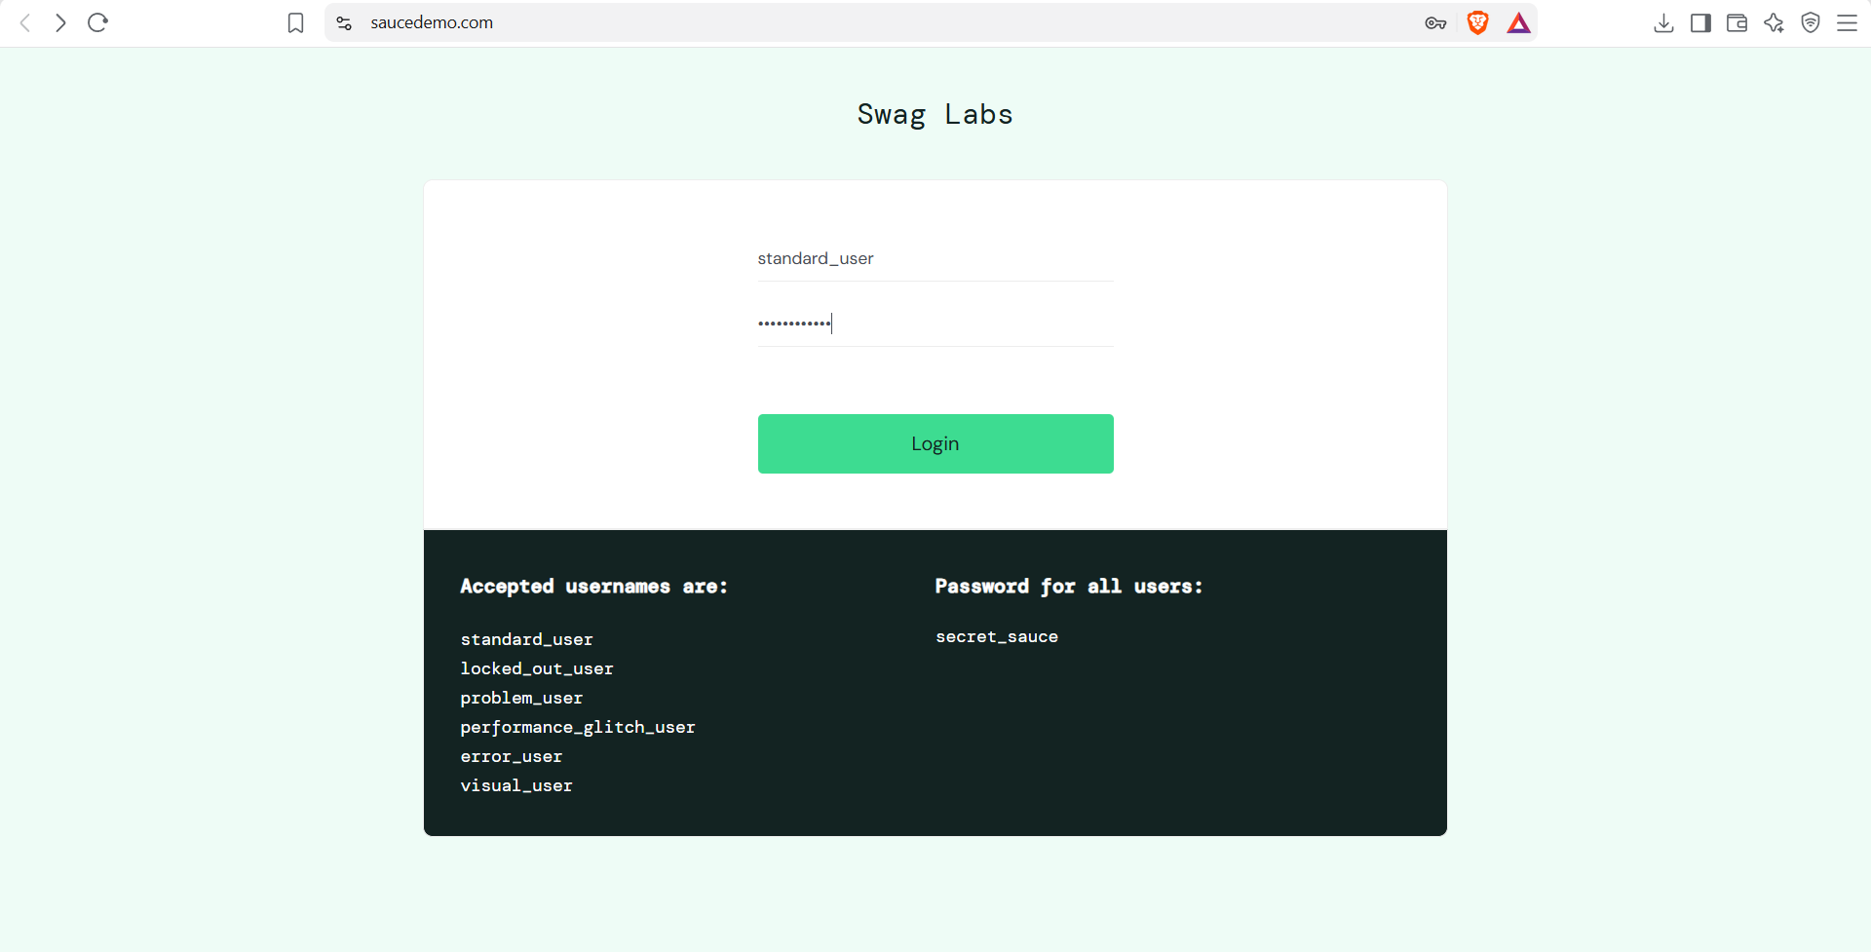

Screenshot 4 — SauceDemo inventory/products page after login.
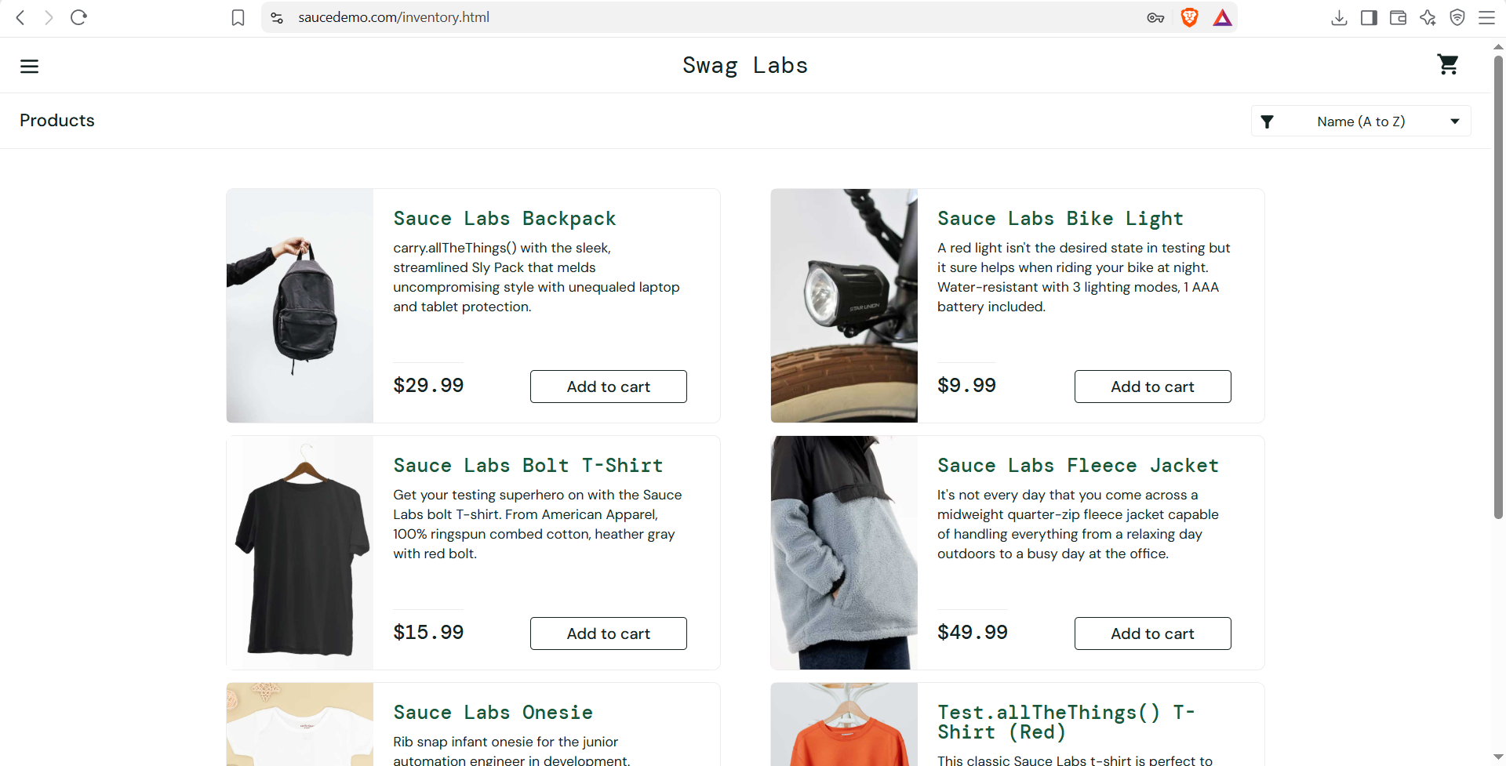

12. Observation
Sr. No. | Observation | Remarks
1 | Chrome was launched through Selenium. | Successful — console output
2 | Login form was automated. | Successful — console output
3 | Product selection was executed. | Reported successful — console output
4 | Cart navigation was executed. | Reported successful — console output
5 | Checkout form was completed. | Reported successful — console output
6 | Multi-page workflow was validated. | Reported successful — console output
7 | Back/forward navigation was executed. | Reported successful — console output

13. Conclusion
Tutorial 11 demonstrates Python-based web automation testing with Selenium WebDriver on the SauceDemo application. According to the supplied console output, the website navigation, login, product selection, cart navigation, checkout form, multi-page workflow, and back/forward navigation checks all passed. The screenshots provide supporting evidence of the Python script, console results, login form, and inventory page.

